Autonomous Drones for Roadway Inspection
By: Casey McCarthy
For the purposes of this article and for your personal referencing conveniences, and on behalf of a 2022 United States Department of Transportation report an official and crucial vocabulary definition and statistic on drones:

“Unmanned Aircraft Systems (UAS), also known as drones, are aircrafts that do not carry a human operator and are autonomous or remotely operated…According to a recent report: The Washington State Patrol documented 125 UAS deployments during their pilot program in 2018 and found at an hourly rate, the operational cost for UAS is $20 per hour.”

Drone functions can be revolutionarily utilized for fast response, security, inspection, construction, agriculture, and even conservation. City use of drones include fire, building, parking, transportation, police department, planning and zoning, tourism and culture, parks and recreation, facilities and fleet management, code compliance, improvement projects (CIP), and environment sustainability.
First responders rely on accurate geographical information which can be enhanced with autonomous drones to coordinate operations, minimize damage, and save lives.
Courtesy of Washington, D.C.’s Office of Community Oriented Policing Services (COPS) as a part of the U.S. Department of Justice, a 2020 Police Executive Research Forum, “Drones: A Report on the Use of Drones by Public Safety Agencies–and a Wake-Up Call about the Threat of Malicious Drone Attacks,” publicly shares the modern relevance and utilization of police drones as they have been crucial even during the COVID-19 crisis, “For example, drones are being used by the Elizabeth (New Jersey) Police Department to disperse crowds and enforce social distancing rules. The Daytona Beach (Florida) Police Department is using two drones equipped with loudspeakers to communicate with the public without getting too close. In the United Kingdom and across Europe, police are using drones to monitor people’s movements and enforce lockdown orders. And in Israel, police are using drones to confirm that those who tested positive for COVID-19 are self-isolating.”
On another but similar first response note, response in the first 72 hours after disaster strikes is critical, which is why the immediate deployment aids rapid incident response as shown in the image below from a news article in the Los Angeles Times, “Fountain Valley police get drone program off the ground.”
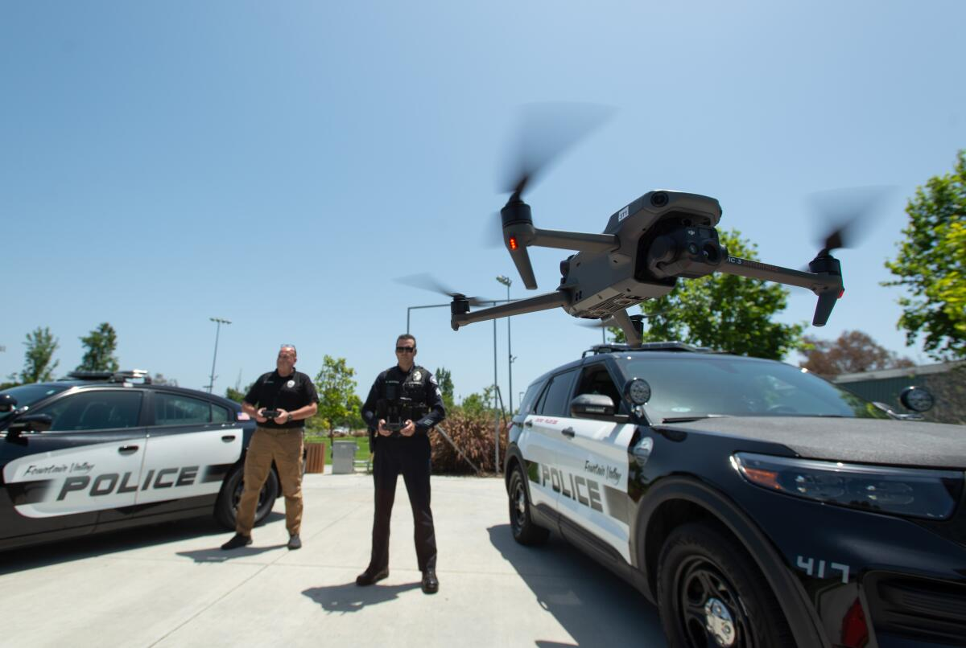
On site construction surveying and inspection can be tedious and hazardous, whereas autonomous drones add to time efficiency and worker safety.
Ronald Knezevich, the State Safety Engineering Supervisor for the Georgia Department of Transportation (as pictured below), manages the funds for the highway safety improvement program and some other federal funds from the traffic control center in Georgia, “all for the primary purpose of reducing roadway fatalities in the state of Georgia.”

As per an interview in July of 2024 Ron elaborated on manual surveying, “It’s a very common method, and kind of where I think drones have the benefit which is not being fully leveraged just because it’s a new industry and the government is always one of the last places to jump on new technological advances.”
Ron mentioned in the process of surveying, “Utilizing drones or even just aerial imagery or other data sources earlier on can make it a lot cheaper and allow us to answer some critical decisions about right-of-way. Drones can detect where utilities are located which informs our decisions on where to add a round-about, sidewalk, or another lane, because it will prevent us from bursting a gas or water line.”
He then noted, “However, a lot of the data sets we utilize in early stages are not very accurate. It’s critical to understand right-of-way lines and underground utility locations very early on in the process because they can tell us it’s not a good place to put our money. Once you’ve spent $800,000 dollars designing a project, you don’t want to then realize you’ve made a mistake.”
Relating to time efficiency, Ron ties in how drones can make a major difference in traffic counts, “In order to calculate annual average daily traffic counts we monitor traffic for 24 to 48 hours,” said Ron then adding, “that’s where drones become an effective tool because we have to complete this process multiple times for every of the thousand projects that we have programmed for the DOT.”
Currently, Ron informed, “For a survey of just a single intersection you’re probably looking at under $100,000 dollars, for a corridor that’s a mile or two long, you’re looking at well above $100,000 dollars, to $200,000 dollars.” Surveys are performed at least once a year, to what Ron could recall, as required by the federal government, “to detect distresses in the road we survey the entire roadway system with a pretty much all-encompassing vehicle.” The Georgia Department of Transportation recently hired Pathway Services, according to Ron, for the use of the survey vehicles (pictured below) that have “lights, infrared cameras, radar, and a lot more.” The vehicles, Ron says, “will detect something as small as an ‘alligator crack’ caused by heat or potholes caused from too much load in one spot.”
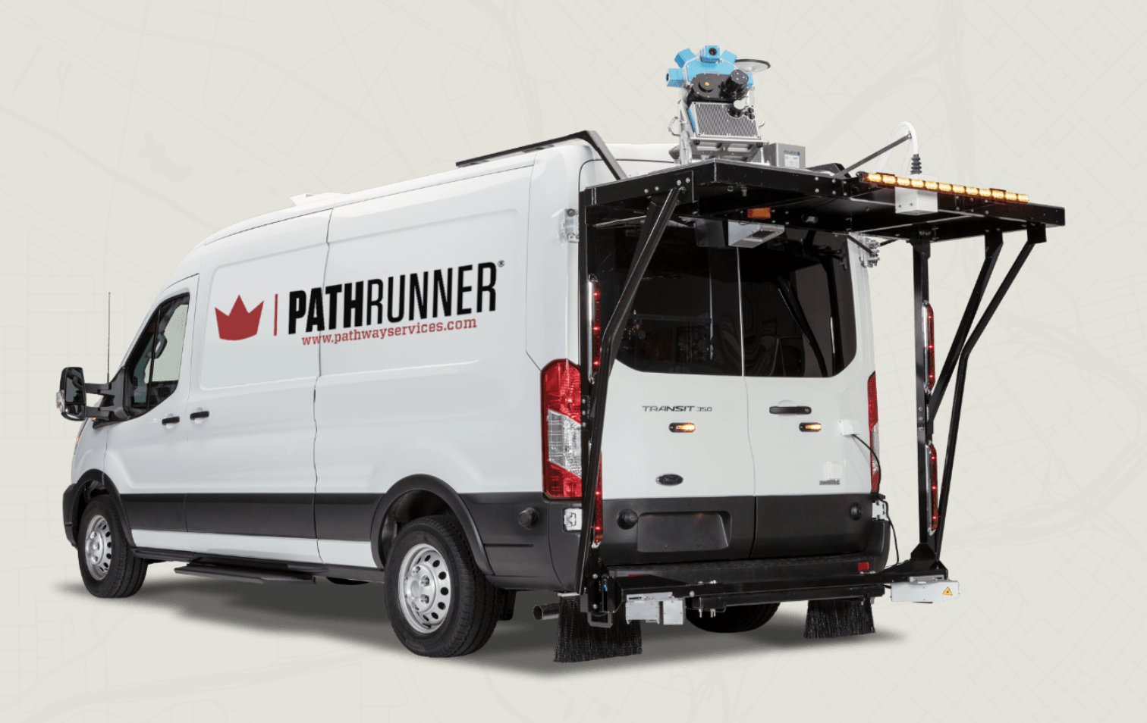
Ron figures a drone can do the job better, “We’re putting that much money and gas into someone driving every road and collecting data which a drone can probably do more time and cost efficiently. It’s really just a matter of a cost comparison.”
The following infographic from Power Engineering’s article entitled “Elevating safety and efficiency: The impact of drone technology on utility inspections,” clearly illustrates the efficiency and cost savings drones provide inspection.
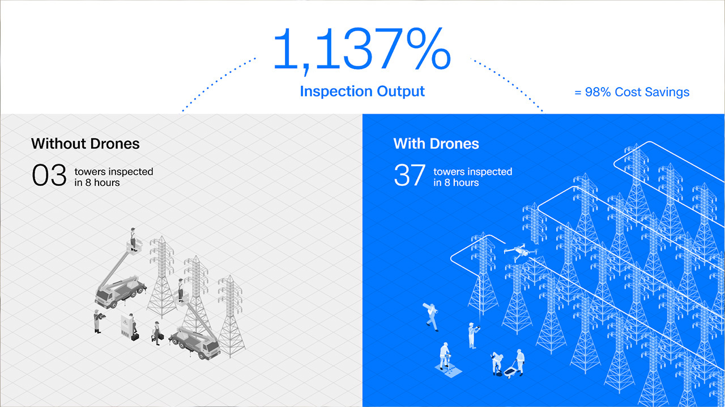
Public safety can utilize autonomous drones for events and crowd monitoring, neighborhood watch, emergency management, and continuous surveillance. Government and law enforcement can operate autonomous drones for traffic control, search and rescue, crime scene analysis, and suspect tracking. Automatic drone flight control software enhances effectiveness and reduces security operational costs significantly by providing unparalleled, continuous security of equipment whilst assuring site progress tracking.
Autonomous Drone Benefits (for Rapid Response, Construction, and Security):
- Immediate launch
- Seamless battery swap (for extensive flight time)
- Extreme weather and tamper resistance
- Seamless and continuous remote surveillance (for asset security)
- Unsafe area access (for site visibility enhancement and worker safety)
- Rapid aerial assessment/analyzing (of damages, dangers, etc.)
- Enhanced live situational awareness/evaluation
- Thermal drone cameras (for suspect and victim detection)
- Data accuracy
- 3D mapping (for accurately recreating crime/accident scenes from real time images)
- Time-sensitive information (for process tracking, project reporting and planning, and rescue coordination)
- Partnering software= automatic flight path generation, live control, and video streaming
- 3rd party alarm integration
- Supply delivery

Drones supply aerial views for inspection and rapid response to a range of infrastructure-related maintenance and crises-amongst a plethora of other uses-such as monitoring road signs, traffic, construction sites, accidents, the state of the pavement and greenery; all useful information to promptly activate law enforcement and rescue teams in case of need and to identify intervention or restoration activities on the infrastructure.
Ron Knezevich elaborates on manual monitoring and maintenance issues, “It’s not just that you can’t see it, it’s that you can’t get the best view angle of it. When we’re trying to track what we call ‘near collisions’ or ‘near misses’ we use AI to compute the speeds of the vehicle, and of the pedestrians. Depending on that camera angle, computing speed can be extremely challenging.”
For reference, Ron expanded upon the difficulty unideal camera angles cause collision calculations, “If you’re looking at something head-on and they’re turning left, computing that speed is not going to be very accurate…You can see speeds incorrectly detecting up to around 20 miles per hour, which is huge when you’re talking about a left turning speed which should only be about 10 miles per hour max.” Essentially, Ron concludes, aerial views eliminate a large portion of manual monitoring issues, “Being able to get above the intersection, and high enough to get that view, and having a drone that is stable enough to record video that detects accurately is very critical.”

How It Works (as demonstrated by the Falco program):
- “Nests” or “Stations” are installed (to house, take off and recharge the drones) to cover their assigned areas.

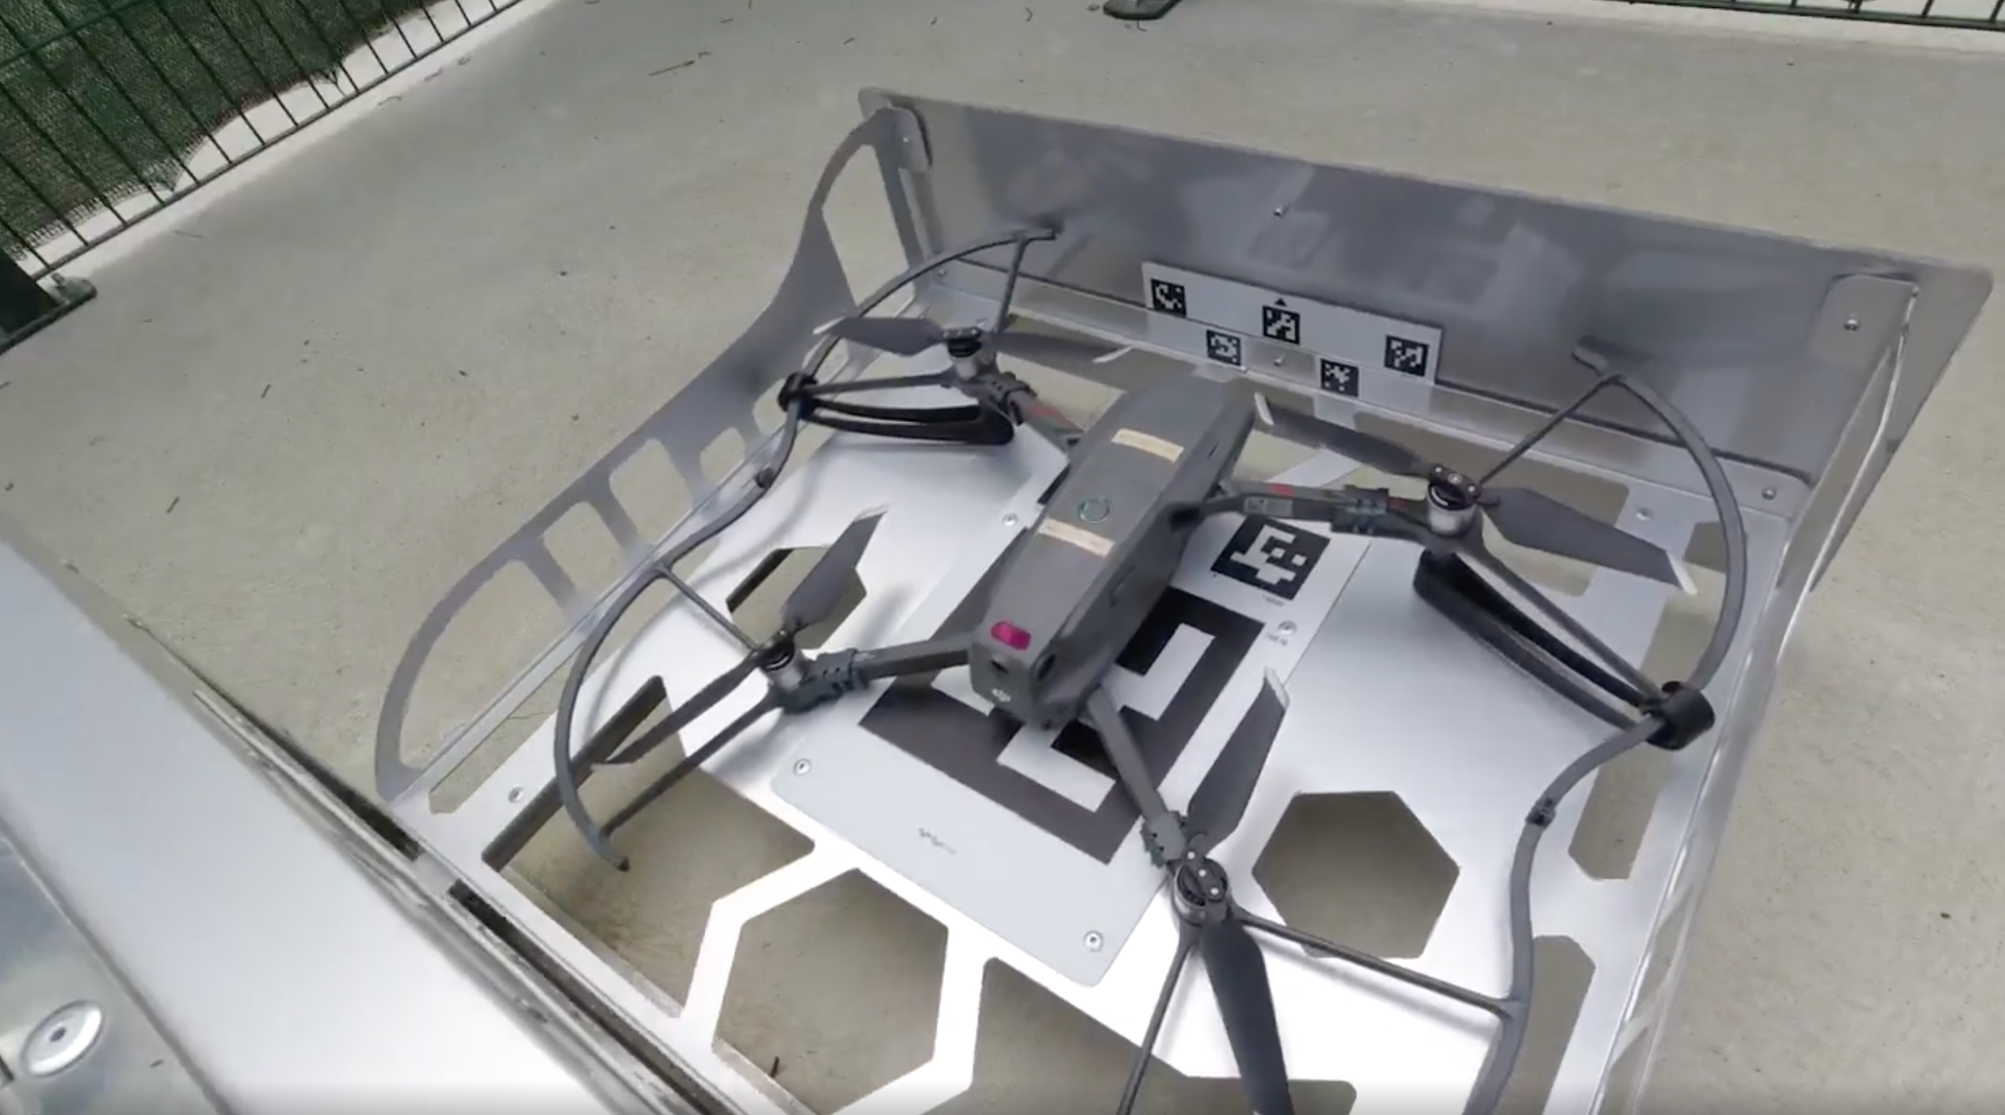
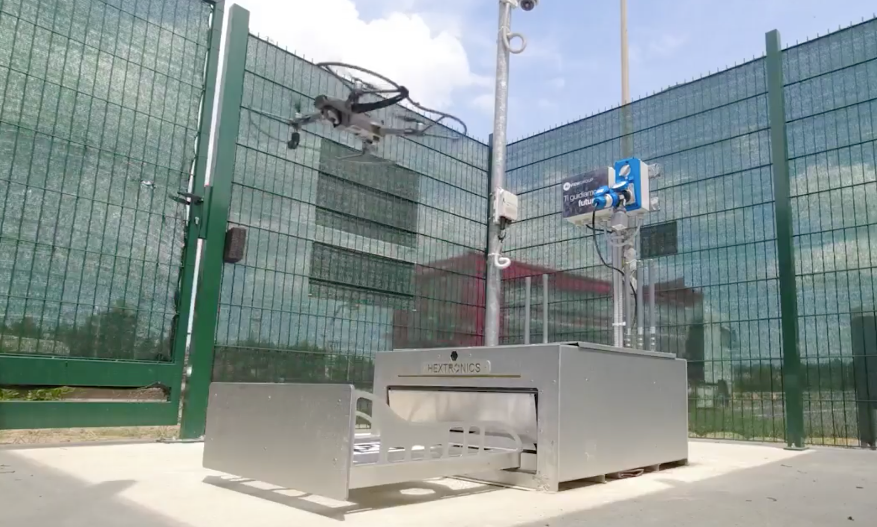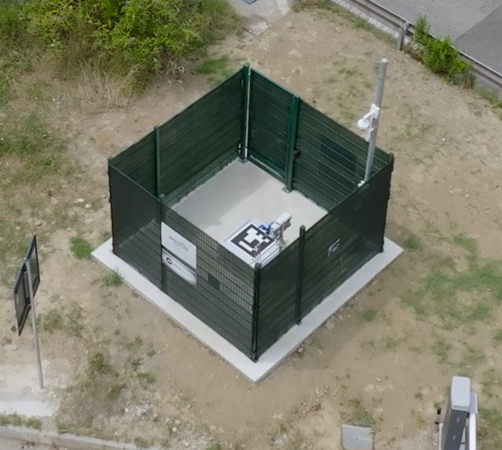

- Flight missions are planned or activated as needed.
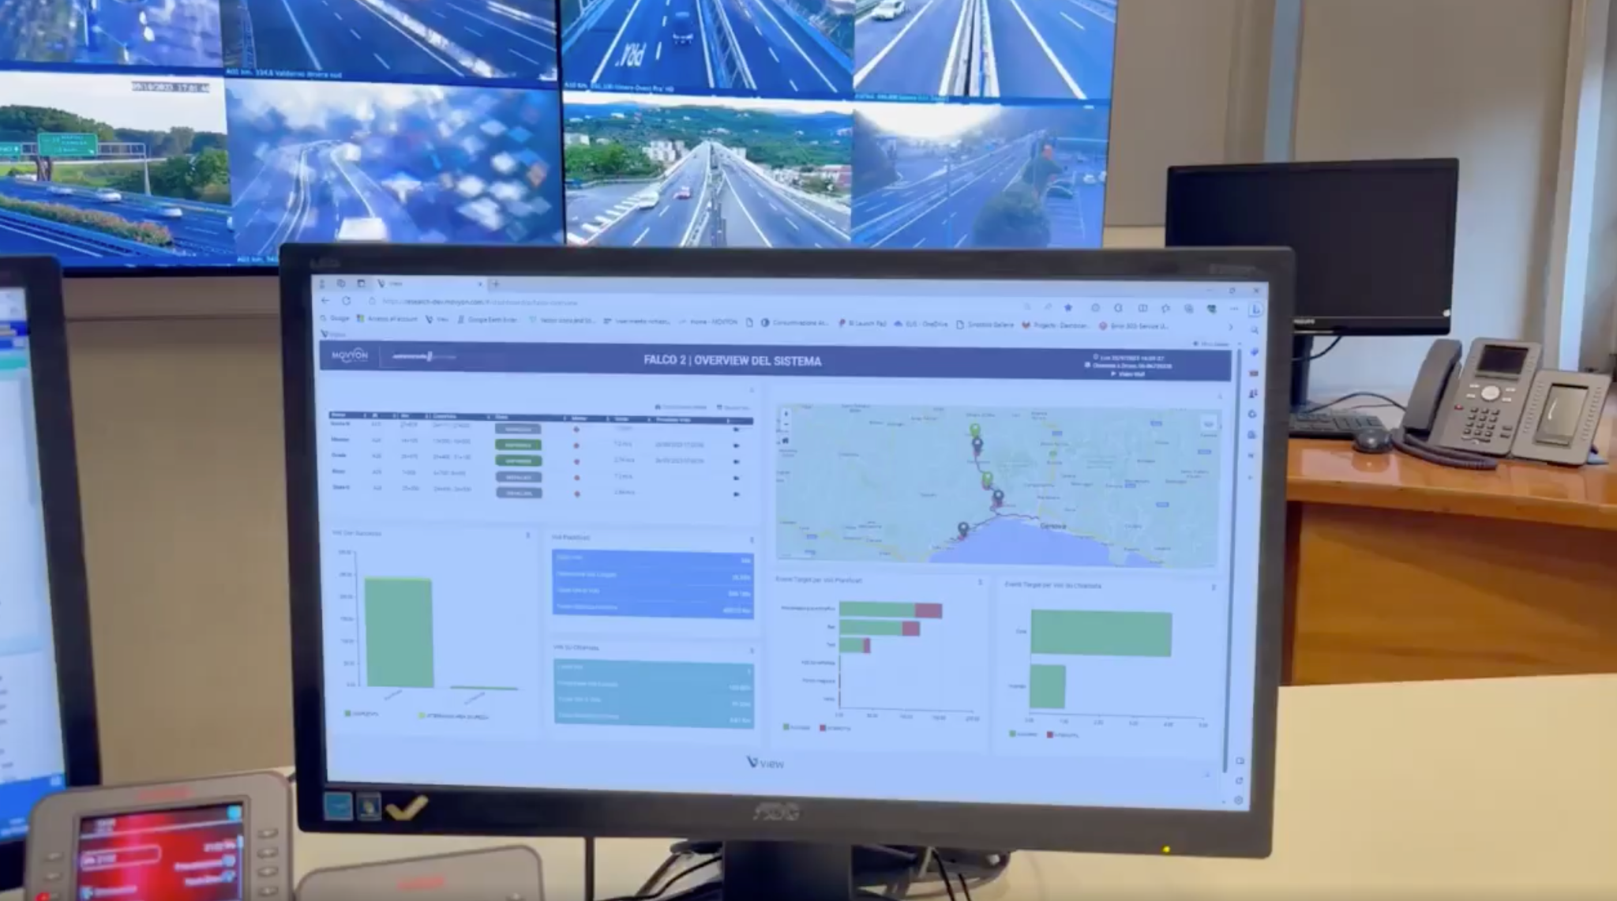
- Drones are remotely piloted from traffic control centers (video and report the roads and infrastructure conditions).
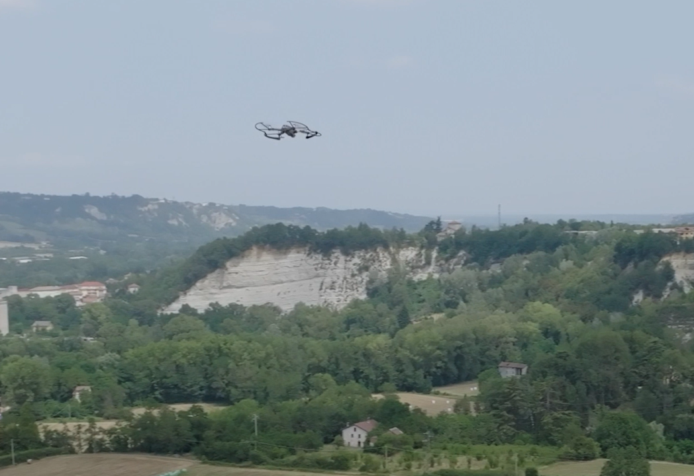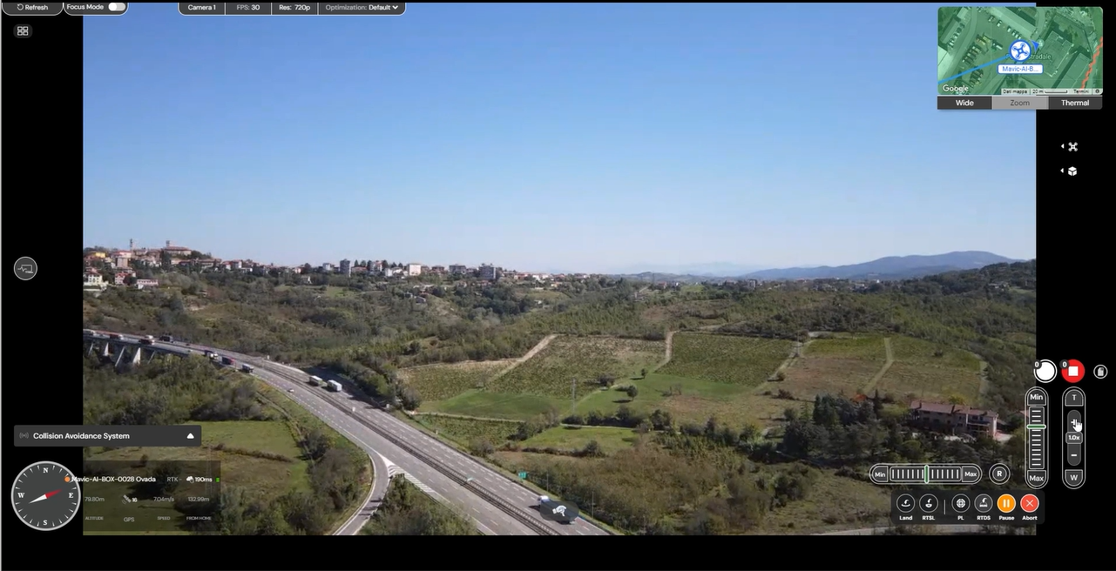
- Data is collected and analyzed (for event detection, i.e., a stopped vehicle, accident, etc. and perhaps eventually for routine patrols).
By eliminating traditional drone issues (i.e., travel to distant/sub-optimal locations, required pilot operation and industry knowledge as well as physical presence, lack of effective data sharing and processing), autonomous drones solve antiquated tech issues by providing user-friendly, time-saving products. The benefits in autonomous drones lie in their ability to maximize on operation time, ensure immediate launch, response, and situational awareness, to name a few.
Beyond drone-specific improvements, the additional benefit of computer vision analysis software tools-to detect cracks, leaks, unstable infrastructure and safety hazards-establish autonomous drones as a universal multi-industry no-brainer by allowing for a more sustainable future in securing motorways worldwide and thus also fostering safer inspection, reporting, maintenance, and transportation experience.
It’s a known fact that current traditional and human-based asset and infrastructure inspection methods-scaffolding climbs, scissor lifts, and others-are time consuming and can be potentially hazardous to workers.
Ron Knezevich relates to these traditional and time consuming, human-based inspection and data collecting methods saying, “My least favorite part of the job as an engineer [in Georgia] is traffic projections. We collect traffic counts and turning movement counts of where the vehicles are going and also where they’re turning at the intersection for 48 hours. From there we try to project that traffic 20 years into the future after the construction project to address the predicted traffic impacts on that project. The projections are all based on census data and what has historically happened, and you’re essentially guessing, and it’s never that good of a guess. It’s very tedious and could maybe even be automated with drones. We don’t need to be spending hours on tedious work that costs thousands of dollars per project. Like I said, we’re only guessing at what traffic will be, the roadway system has been around less than 200 years in America, and we’re projecting traffic out a tenth of that time.”
Meanwhile, unlike human-based inspection and collection methods, manual drones can cut times and costs, but are complex to operate, fail to work in GPS-denied environments, and have untrustworthy obstacle avoidance, leading to many hours of training to mitigate the risk of crashes. Autonomous drones, however, eliminate the need for workers to physically access hostile environments due to their ability to inspect difficult-to-reach areas (i.e., bridges and viaducts) whilst collecting high-resolution data.
Regardless of any possible autonomous drone challenges, in the 2018 article, “Ready for Takeoff,” by the United States Department of Transportation Thomas Everett, associate administrator for the FHWA Office of Infrastructure states as fact from his professional experience, “‘The benefits of unmanned aerial systems far outnumber the challenges to implementation.” As evidenced from the testing that has been “underway across the country,” and Everett is “looking forward to transportation agencies realizing the safety, time, and cost savings compared to using traditional practices for these transportation applications.’”
Also, according to a 2019 DOT Bridge Inspection Report, “The Minnesota Department of Transportation (MnDOT) is utilizing drones to collect and process large amounts of data during bridge inspections with the goal of improving the quality of bridge inspections and improving safety for both inspectors and the traveling public.” The report states “In the summer of 2015 and 2016, a research team implemented Unmanned Aerial Systems (UAS) technology on 39 bridges…to demonstrate the benefits and challenges of employing UAS on a large scale.”
Evidently, the findings of this report conclude “Drones can reduce the safety risks of bridge inspectors by removing or reducing the need for traditional access methods such as Under Bridge Inspection Vehicles (UBIVs), rope access, ladders and scaffolding. Additionally, drones can reduce the risks posed to both the public and bridge inspectors by eliminating the need for traffic control and the need for inspection personnel to work near traffic.” Moreover, the findings clearly affirm “The cost savings from removing traditional bridge access methods were significant – ranging from $540 to $21,000, with an overall average cost savings of 40 percent. Even where there were no cost savings exhibited, the quality of the deliverables was greatly improved.”
Much like people, autonomous drones deploy quickly, and require minimal downtime for equipment. With their flexibility, they even suit a majority of inspections (pipeline, powerline, solar PV, etc.). As a cherry on top, systems such as wind turbines, for example, don’t have to be shut down to avoid damage or injuries to the inspection personnel.
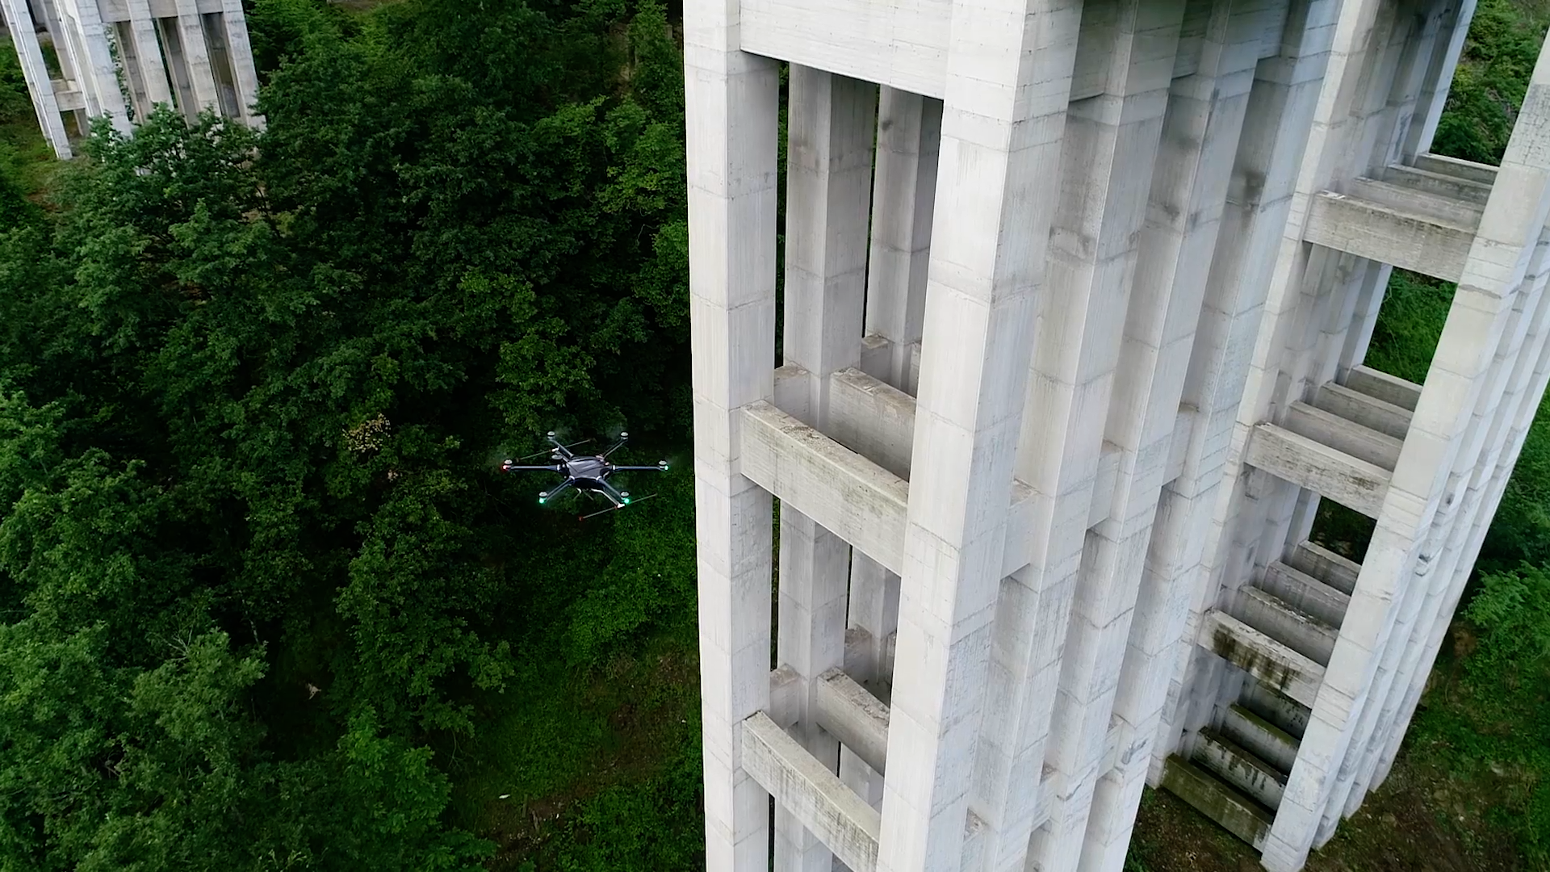
Ron Knezevich testifies to the flight maneuver adaptability drones provide, “Right now we [Georgia DOT] are utilizing aerial imagery wherever possible for that which is then run through a computer vision algorithm. That is in its infancy stages, for sure, so it’s hard to say how accurate that is, but that aerial imagery data can be fairly accurate, but a lot of times, if it’s taken in the wrong season it’s “tree-on” is what they call it, where trees are blocking pretty much all your assets, which drones can navigate under.”
“One thing I do not think is on the market now is utilizing drones for just asset collection,” Ron reflects, “whether it’s just locating guard rails, sidewalks, bike lanes, medians, and their dimensions. Pedestrian fatalities represent 20% of our total roadway fatalities but less than 1% of our crash data. Having more data, whether it’s related to near misses or pedestrian assets, or updates on the conditions of traffic signals-anything you can detect through video or radar analytics-is very valuable.”
Ron sees a way in which drones can make American roadways safer with asset and data collection informing our crash countermeasures, “Many other countries’ transportation agencies are showing decreases in the roadway fatalities, but across the United States we’re showing an increase over the last ten or so years. Especially with COVID, people started speeding more during the pandemic, so we’re seeing higher speeds on the roadway leading to higher severity collisions.”
Moyvon Technology published an article on July 23rd of 2024, entitled, “Autostrade per l’Italia, Remote Drones for Traffic Monitoring. The Results of the Second Phase of the Experimental Program Started with ENAC,” covering Italy’s current pioneering work with autonomous drones, a system, Aspi (Australian Strategic Policy Institute) CEO Roberto Tomasi has stated, “places us at the forefront of technological innovation worldwide.”
According to Movyon’s article, Aspi’s Falco project-a collaborative initiative with Movyon-is now supporting Autostrade per l'Italia traffic teams and monitoring traffic with remotely piloted autonomous drones from a Genoa traffic control center.
The Falco project focuses “on five sites of the Ligurian section of the motorway network, chosen for its particular structural characteristics and which crosses a complex territory from an orographic point of view.” This cutting-edge technology is in accordance with ENAC, the Italian Civil Aviation Authority; one of the most advanced authorities in Europe in the field of unmanned aircraft on board.
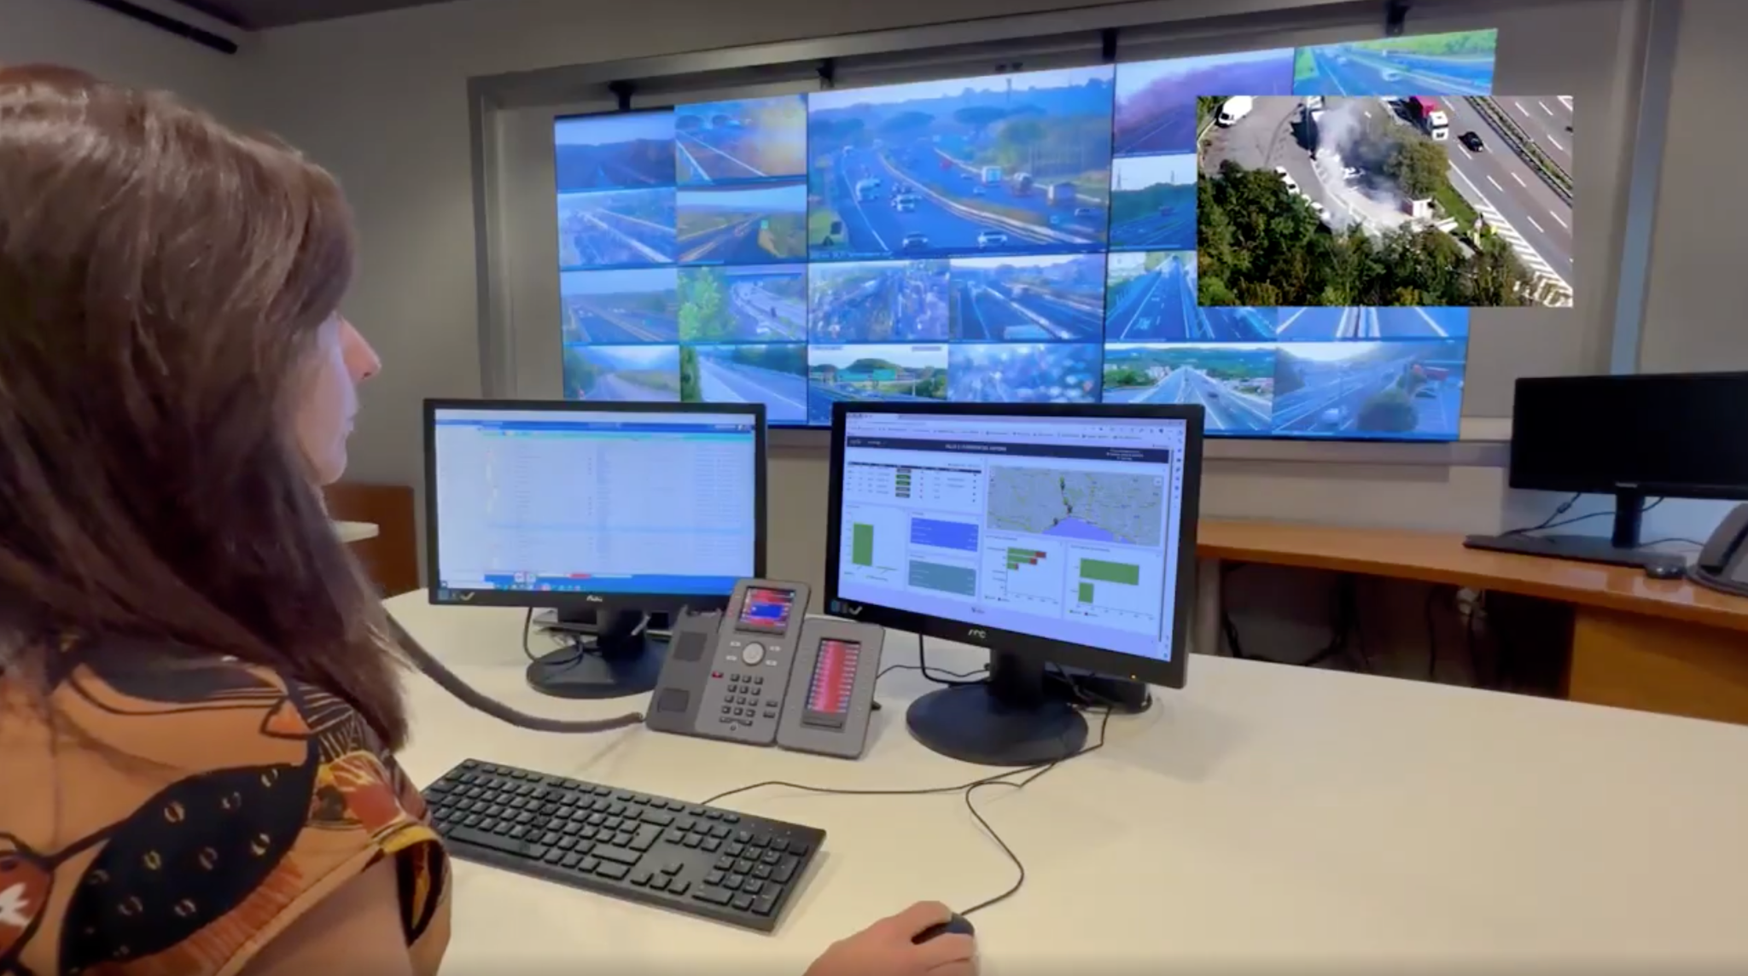
Statistics from the Falco Project (August 23 to July 24), as according to the article:
- 1407 planned missions
  - Success (missions launched and completed) rate= 82%
  - Of the 18% of missions not launched, 70% were due to bad weather
  - 191 hours of flight/1,762.83 miles
- 53 on call missions
  - 12.5 hours of flight/with 52.19 miles
- Results
  - 11% ↑ in detected events
  - 50% ↓ in intervention times
In short, autonomous drones and hardware products that support drone autonomy-like those designed and sold by Hextronics-begin a new era of fundamentally more efficient innovative technology and safer world at large. “With the Falco Project we are testing the use of drones to monitor traffic in real time,” explains Tomasi, CEO of Autostrade per l'Italia, “so that we can increasingly better manage traffic flows, increasing safety for users.” Tomasi continues to state their “ultimate goal is to arrive at a digitalized and automated network that provides an ever-increasing amount of timely and immediate information to those who travel on it and to those who manage it.”
It is to be noted that the following calculations are made by using comparative reported data from separate drone programs across the world. These calculations are not to be considered an exact measurement, but rather a researched estimation. The purpose of these proposed estimations is to gather a broad range of comparative statistics in order to provide cost-benefit analysis on helicopter versus autonomous drone utilization in police surveillance of traffic and other such operations.
The Falco program would’ve saved an estimated $590,150 in operation costs in utilizing drones over helicopters for 203.5 total flight hours (191 of scheduled flight and 12.5 hours of flights on call) of traffic monitoring and a striking $46,400,000 for 16,000 total annual flight hours.
These estimates are calculated by factoring in the rate of helicopter cost per flight at $2,900 and 16,000 annual helicopter flight hours, both according to the 2023 CBS News article, “Audit says LAPD’s use of helicopters ‘causes significant harm to the community,’” as it broadcasts the coveted audit data stating, “The city operates their helicopter fleet on a nearly ‘continuous basis’...logging an average of 16,000 hours of flight time per year. The total translates to more than $2,900 per flight hour.”
Comparatively, the operating cost for drones lies at a jarring zero dollars and zero cents. Burbank, California’s Police Drone Program confirms LAPD’s estimated costs stating, “The drone costs next to nothing to operate, while the helicopter can run upwards of $1,000 per hour to operate.”

Hamilton Sheriff Charmaine McGuffey in Ohio, calls helicopters “flying dinosaurs.”

McGuffey’s statement was quoted in the 2022 Police1 article, “Ohio sheriff’s office ditching its helicopter in favor of drones,” when speaking to the county commissioners about their exorbitant cost in comparison to drones “according to Local 12 News.”
Not only should the economic costs of helicopters be considered excessive in comparison to drones, but we must also face the environmental costs of the superfluous amounts of fuel required to sustain these cumbersome vehicles. According to the CBS article, “the controller's office says that they [LAPD] burn approximately 761,000 gallons of fuel annually — 47.6 gallons per hour,” a rate reinforced by the 2023 ABC News article, “Should law enforcement helicopters fly so much? UCLA study looks into impact of emissions,” as UCLA Professor Nicolas Shapiro “looked at data from October 2019 to October 2020 and figures LAPD helicopters used about 766,000 gallons of fuel.” There is only a 5,000-gallon difference between the LAPD audit’s data analyzed from 2018 to 2022 (reported by CBS) and UCLA’s LAPD emissions study data from 2019 to 2020 (reported by ABC News).
From UCLA’s study’s findings, the ABC article reasons that “An average car might use about 500 gallons a year - so that means it is the equivalent of about 1,500 cars on the road.” Moreover, from the audit, the CBS article forms the damning conclusion that this immoderate rate of fuel burning in turn releases “7,427 metric tons of carbon dioxide in that time frame.”
Not to mention that LAPD’S helicopter program comprised of “17 helicopters and over 90 employees,” as the CBS article relates, evidently “spends just over 60% of flight time on incidents considered to be ‘low-priority,’ costing nearly $50 million annually to taxpayers,” all of which harms the community, as City Controller Kenneth Mejia’s office said in a statement, “‘without meaningful or reliable assessment of the benefits it may or may not deliver.’”
Constellation Clearsight-an electric grid inspection company-confirms that “Electricity is far less expensive than aircraft fuel, but even if you are using a gas-powered or hybrid drone the fuel consumption will be a fraction of the helicopter by comparison.” Additionally, Clearsight expands, it’s “much easier to get than a pilot’s license to fly manned aircraft” because “The requirements for a commercial Part 107 certificate are far less prohibitive and time consuming,” which makes drones a more accessible tool to utilize.
In startup costs alone, helicopters, as Clearsight has stated, “On average, a fully equipped helicopter will cost more than $2M,” which the 2024 ABC New article, “DC police unveil new ‘Flacon 1’ helicopter, drones, increasing tools for crime fighting,” attests by noting the $6.2 million dollar price of Washington D.C. Police Department’s newest high-tech helicopter. Clearsight continues to inform that “an equally compatible drone will come in the range of $250k or less.” Likewise, the five drones in D.C. Police’s new Falcon 1 “program cost around $15,000 each, according to MPD officials.”
As a measure of success of the D.C. Falcon 1 program with the support of their five drones, it should be noted that the article reports that “overall crime in the District is down 17% when compared to last year,” and “So far in 2024, the MPD Air Support Unit has responded to 493 calls for service and assisted officers in conducting 76 arrests.”
Moreover, Clearsight mentions additional helicopter costs to consider, “which consist of a highly trained pilot and flight crew, fuel, daily maintenance expenses, insurance, and mobilization charges. Processing, analyzing, and scoring data into actionable insights can affect costs as well.”
Clearsight ventures to state, “The average daily rate will range anywhere from $9,000 to $30,000 depending on the level of detail in the work scope,” further proving drones to be a cost-effective alternative to helicopters. In comparing the results of an inspection of an overhead distribution line over highway crossing between the drones and “a separate ground-based crew who inspected the same assets…The aerial team identified 48% more conditions than the ground team, and 4 high-priority issues were only identified by the aerial team.” In conclusion, the data proved aerial inspections to be more thorough and better at prioritization.
According to Drone Fly’s Police Drone Infographic, “Police departments, on average, can expect to incur costs ranging from $35,000 to $55,000 to initiate a drone program that includes two drone systems.”
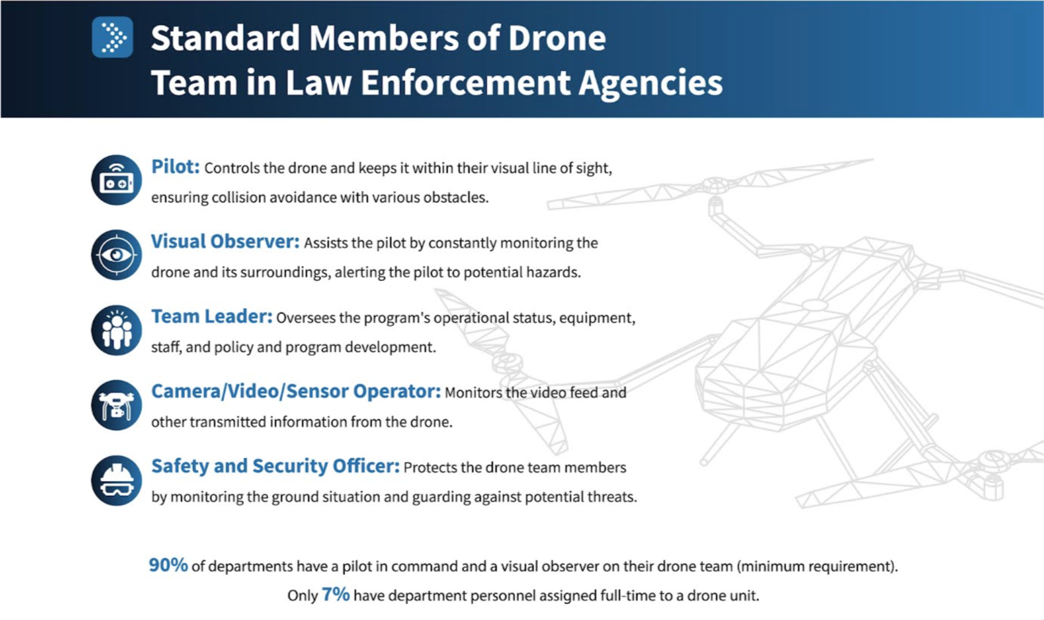
Drone Fly’s infographic data report goes on to state, “Florida’s Polk County Sheriff’s Office, in the initial 18 months of their drone program, conducted over 750 missions, leading to the arrest of 31 suspects and the successful location of five missing or endangered individuals. It saved tens of thousands of dollars in the process.”
Speaking of saving lives and costs, Ron Knezevich informs us, “One big misconception is the roads are perfectly safe and all up to standard, and that couldn’t be less true. We just have to figure out how to prioritize improvements based on what’s most cost effective. A lot of my work goes into finding out what designs to grade as well as how they can most cost effectively be placed, doing cost estimations and seeing what crash reduction we get, which translates into an economic value as well.”
Don’t be alarmed, though, Ron assures us that what’s most cost effective for the state is saving lives, “Just in a government industry it’s interesting how a benefit cost analysis is actually saving human lives. If you’ve ever wondered what the cost of a human life is in the traffic industry, it’s $12.5 million dollars in Georgia. We try to quantify it and that’s how we prioritize things.
According to the 2018 U.S. DOT article, “Ready for Takeoff,” The Gwinnett County Police Department in Georgia “first used a drone in 2016 to investigate serious traffic crashes.”
Ron Knezevich warns us, “One thing to note, the word ‘accident,’ implies no one is at fault, we [Georgia DOT] always use ‘crash’ or ‘collision’ just because it’s more truthful as it’s a shared responsibility across everyone. There is someone at fault. The state gets sued all the time if things aren’t up to standards, but of course it has to be proven that the state is what caused that crash to have happened and usually the vast majority of crashes have some sort of human error that is the primary cause of the crash. Just because something is up to standards does not mean they’re designed safely.”
Relating back to investigating serious crashes in Georgia with a drone, the department found that the “technology gives them a more complete view of the scene and saves time compared to waiting for a fire department ladder truck or using the police helicopter.”
At the end of our interview, Ron Knezevich shared that his favorite part of his job “is being able to talk to the citizens about what we actually do, the public service agency as well. When we do projects, we can usually get really good feedback and we can actually save lives.” Ultimately, autonomous drones can save roadway inspection time, money, and lives.

